**Subject: English**

**Class 6**

**Literature:**

* Matilda Chp. 1-10

**Grammar:**

* Simple Past tense
* Active/Passive Voice
* Direct/Indirect speech
* Conditionals (first conditionals)
* Similes and Metaphors
* Figurative language (simile, metaphor, personification, sounding words with poetry)
* Noun Phrases
* Compound Sentences
* Comparatives and Superlatives
* Phrasal Verbs
* Second Conditionals
* Verb phrases and Prepositional phrases
* Figurative language- Personification and oxymoron
* Conjunctions

**Creative Writing:**

* Narrative writing
* Create a leaflet
* Account Writing
* A Newspaper Report
* Journal Writing
* Create a Poem ( free verse)
* Descriptive Writing
* Dialogue Writing
* Create a Ghost Story
* Reconstructing text: Fairy tale/Legend to a different ending
* Report Writing
* Create a Role play
* Describing a Painting
* Diary Writing

**Comprehension:**

* Unit 1-4

**Subject: History**

**Class – 6**

|  |  |  |  |  |  |  |  |  |  |  |  |  |  |  |  |  |  |  |  |  |  |  |  |  |  |  |  |  |  |  |  |  |  |  |
| --- | --- | --- | --- | --- | --- | --- | --- | --- | --- | --- | --- | --- | --- | --- | --- | --- | --- | --- | --- | --- | --- | --- | --- | --- | --- | --- | --- | --- | --- | --- | --- | --- | --- | --- |
| |  |  |  | | --- | --- | --- | |  |  | | | * **World History;**   Civilizations of the Ancient World: Mesopotamia | | Week # 2 | | | Ancient Egypt of the Pharaohs | | Week # 3 - 4 | | | * **Project Work** | | Week # 5 - 6 | | | * **History of the Sub-continent;**   The Indus Valley Civilization | | Week # 7 -8 | | | The Arya People From the North | | Week # 9 - 10 | | | Ancient Kingdoms of the Arya People | | Week # 11 - 12 | | | The Golden Age of Hindu Rulers |  | | | * **World History;**   The Progressive Civilization of the Chinese | | | | |
|  |
|  |
|  |
|  |

*

**Subject: ICT**

**Class -6**

* Learning the basics
* Creating a document
* Getting online

**Subject: Islamiyat**

Class 6

* Quranic Passages
* Ahadith 7& 8
* Prescribed Duas (2:201-Al Quran & Dua at the graveyard)
* Articles of Faith (Tauheed)
* Pillars of Islam (Hajj)
* Cleanliness

Biography of the Holy Prophet (S.A.W.W)

**Subject: Mathematic**

**Class – 6**

|  |  |
| --- | --- |
| **Sub-Strands** | **Topic/Concept** |

1. **NUMBER THEORY AND ARITHMETIC**

|  |  |
| --- | --- |
| * Number System | Primes, Highest Common Factor  and Lowest Common Multiple |

* Factors and Multiples
* Estimation
* Integers Integers, Rational Numbers

and real Numbers

* Rational Numbers

1. **GEOMETRY AND MEASURES**

* Basic geometrical Basic geometry

concepts and properties

* Symmetry

1. **STATISTICS AND PROBABILITY**

* Bar graphs / Pictograms Statistical Data Handling /

/ Central Tendency Mean, Median and Mode

**Subject: Geography**

**Class – 6**

|  |  |  |
| --- | --- | --- |
| *Basic Skills |  |  |
| *Weather and Climate (Project) |  |  |
| *The Land of Pakistan |  |  |
| *The Environment |  |  |
| *Industries |  |  |

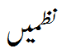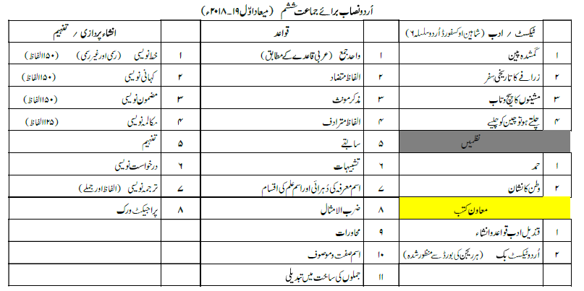

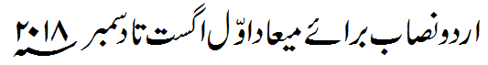



**Subject: Science**

**Class – 6**

|  |  |
| --- | --- |
| * Introduction to Science |  |
| * More about dissolving |  |
| * Micro-organisms |  |
| * Physical Quantities and Measurements * Forces * Project |  |
|  |  |