Question Bank for Class 6
Q1.
- List the factors of 24
- List the prime factors of 18
- Write 24 as a product of its prime factors.
- List three multiples of 24
Q2.Complete the table below:
Check the divisibility for the given numbers.
Numbers | 2 | 3 | 5 | 6 | 9 | 10
6165
5520

Q3.
- Write down the two cube numbers between 10 and 100
- Write down the two prime numbers between 30 and 40.
- Find the LCM and HCF of the following
- 75 and 50
- 24 and 74
Q4. In a group of students
30 play cricket,
38 play football and
9 play neither cricket nor football.
Find the lowest possible number of students in the group.

Q5a) Find the squares and square roots of the given numbers.
    - $√784$
    - ${16}^{2}$
  - Find the cubes and cube roots of the given numbers.

    - $\sqrt[3]{27}$
    - $6^{3}$
  - Evaluate the following.
    - (-4) x 1 x (8) ÷ 2 x 4 II. (-3)² – (-4 x 3) + (1 x 4²)

  - Work these out.
    - 7.45 – 4.33 II. 36 + 4.3
III. 0.105 × 0.2
  - Write the following in ascending order.
$\frac{66}{100}$, 0.6666, 0.67,$\frac{666}{1000}$

  - The Sum of square of two numbers is 100.
    - Find the sum of those numbers.
    - What is the product of those two numbers?
  - Evaluate
  - i) 3 $\frac{1}{5}$ - 2 $\frac{3}{\begin{aligned}4 \\ \end{aligned}}$ ii) 1$\frac{7}{8}$ $÷$ $\frac{3}{16}$
  - It is given that$\frac{2}{3}$, $\frac{8}{d}$ and $\frac{n}{39}$ are equivalent fractions. Find the value of d and the value of n.

Word Problems
- A group of people were standing in line. ³/₈ of the people were boys and ¹/₄ of the people were girls. How much of the group was made up of boys and girls?
How much of the group was not boys or girls?
5/8
3/8

- Jane and Jerry were counting the months until their birthdays. Jane said³/₄ of the year would pass before it was her birthday. Jerry said he only needed to wait ¹/₃ of the year. How much longer did Jane have to wait than Jerry?____5/12______of the year
Change your answer to ‘how many’ months.
5 months

- Bill ran around ²/₃ of the track. Josh ran around ⁵/₆ of the track. How much farther did Josh run than Bill?
1/6_____of the track
- A box of paper clips fell on the floor. Betty picked up ²/₅ of the paper clips and Joanne picked up ³/₁₀. How many of the paper clips did they pick up altogether?
Answer: 7/10 of the paper clips
how many were still on the floor?
Answer: 3/10 of the paper clips
- How many sweets would be in a bag of 28 sweets after ¼ of them had been eaten?

- A paint mixture is made up of $\frac{3}{20}$ red paint and $\frac{9}{20}$ blue paint and the rest is white.
- What fraction of the mixture is white paint?
- The paint is sold in 5-litre containers. How many litres of red paint are needed for each container?
- How many litres of blue paint are needed for each container?

- Jason has 5 feet of rope. If Jason cuts the rope into ¼ foot pieces, how may pieces will he have?

Rounding Off
1. Round off each of the following to the nearest whole number.
(a) 8.71
(b) 26.01
(c) 69.48
2. Round off the decimal:
(a) 3.153 to the nearest tenths
(b) 10.126 to the nearest hundredths
(c) 5.0014 to the nearest thousandths
3. Find the value of
(a) 23.37 correct to 1 decimal place
(b) 1.2003 correct to 3 decimal places
(c) 7.755 correct to 2 decimal places
Integers

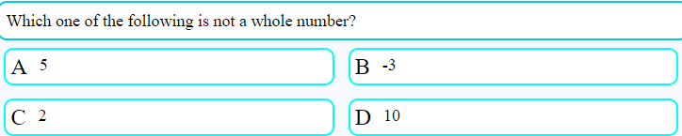
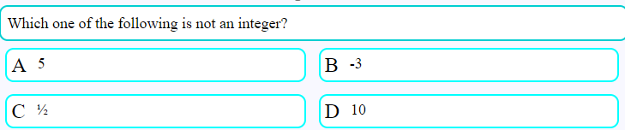
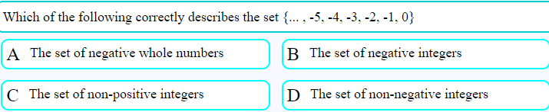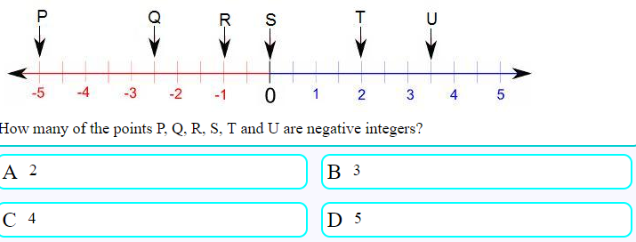
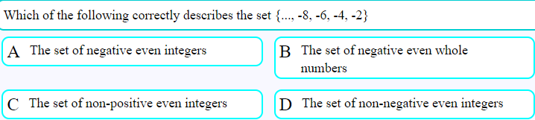
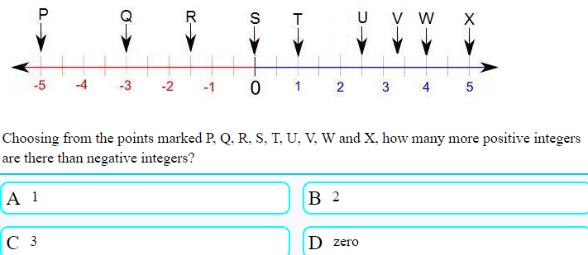
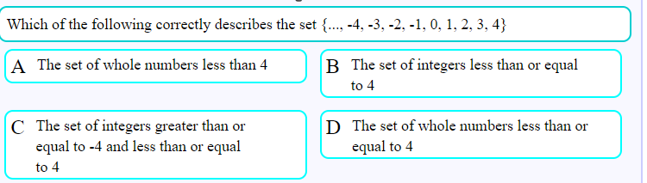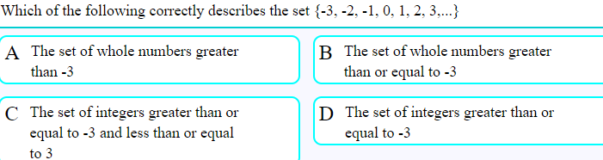
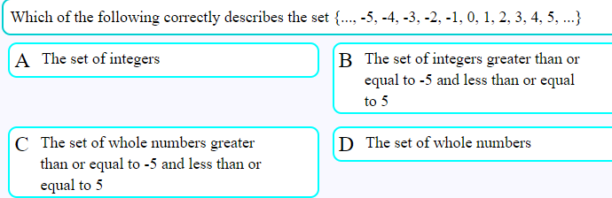
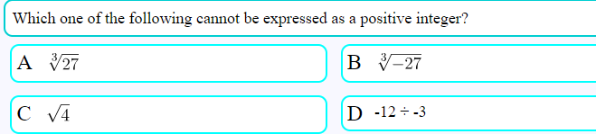

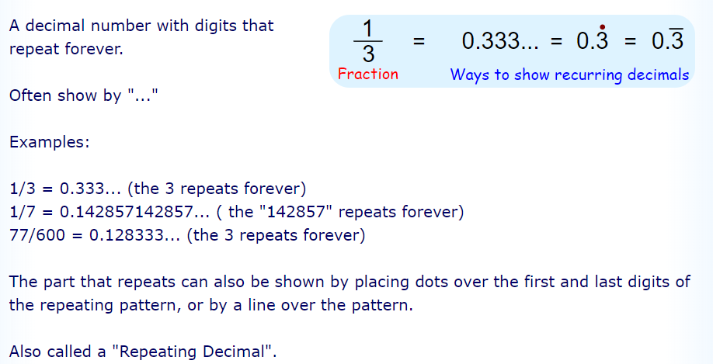
STATISTICS
Q1. Find the mean, median, mode, and range of each set of data set of data
A. 1 1 2 3 3 4 4 4 4 5 5
B. 3.2 4.8 5.6 5.6 7.3 8.9 9.1
C. 1 2 3 4 4 3 2 4 2 3 6 4 0
D. 17 23 36 112 18 23 40 23
E. 1 2 0 2 1 0 2 3 4 1 5 0 3 2 1
Q2. Two discus throwers keep a record of their best throws (in metres) in the last ten competitions.
Discus thrower A | 32 | 34 | 32 | 33 | 35 | 35 | 32 | 36 | 36 | 35
Discus thrower B | 32 | 30 | 38 | 38 | 33 | 34 | 36 | 38 | 34 | 32
As a coach, you can only choose one of them for the next competition.
Which would you choose? Justify your choice mathematically.
Q3. The mean mass of the 15 players in a rugby team is 85.2kg. The mean mass of the team plus a substitute is 85.4kg. What is the mass of the substitute?
Q4. After 8 matches a basketball player has a mean of 27 points. After ten matches his mean was 31 points. How many points in total did he score in his last two matches?
Q5. A factory makes tins of tomatoes. On the average, a full can should weigh 410g. A sample of 20 cans is tested. The weights are shown below.
410 410 411 412 408 411 409 414 416 410
410 412 413 415 410 415 409 410 412 411
Does the canning machine need to be adjusted ? Give reasons for your answer

Complementary vs Supplementary
A related idea is Supplementary Angles - those add up to 180°
How to remember which is which? Easy! Think:
- "C" of Complementary stands for "Corner" (a Right Angle), and
- "S" of Supplementary stands for "Straight" (180 degrees is a straight line)
Or you can think: when you are right you get a compliment (sounds like complement).
Or you could also think: "Supplement" (like a Vitamin Supplement) is something extra, so it it bigger.
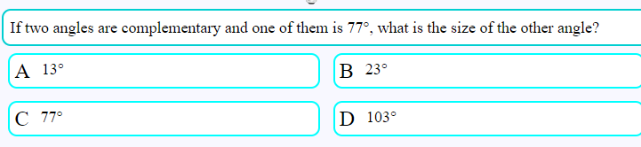
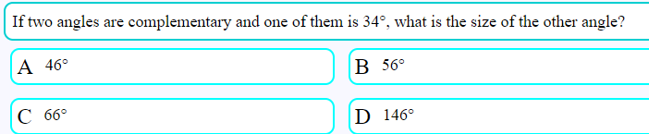
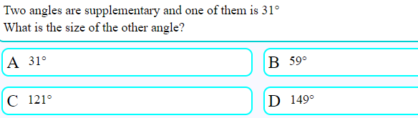
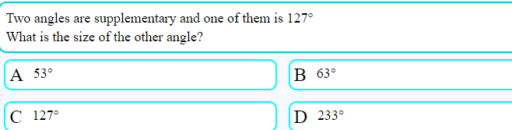

Symmetry

1. Draw the line of symmetry in the given shapes.

2. Draw and write the number of line of symmetry.
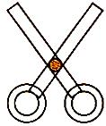
3. Is this shape symmetrical?

