Teacher Name: Aqsa Kamran Class: 7 Subject: Mathematics Date:-01-02-19

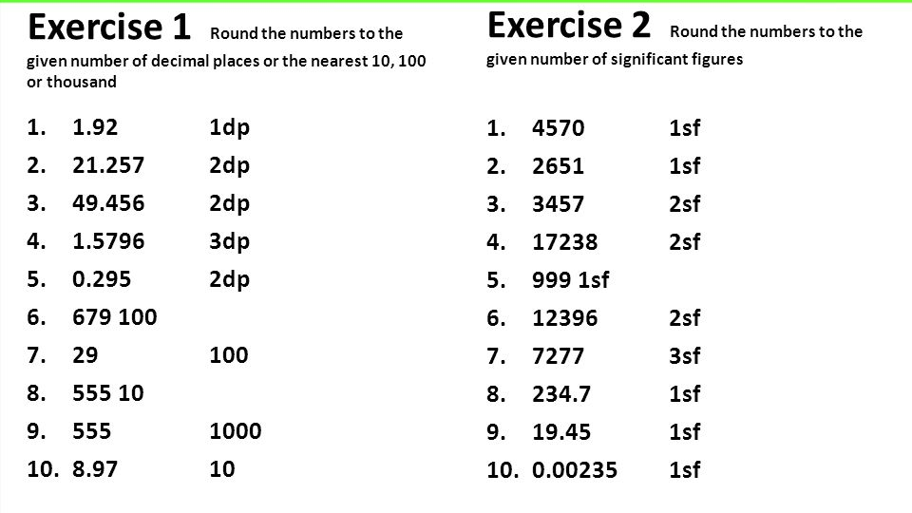

EXERCISE 3
Evaluate each of the following and correct your answer to 1 significant figure.
1.$\frac{6.01X0.0312}{0.0622}$ 2.$\frac{12.01X4.8}{2.99}$

