Teacher Name: Aqsa Kamran Class: 7 Subject: Math
Date: 1st March, 2019

We will practice the questions given in the worksheet on volume of a cube and cuboid. We know the volume of an object is the amount of space occupied by the object.
1. Fill in the blanks:
(i) The volume of a rectangle box (or cuboid) = ________ × ________ × ________
(ii) The volume of a cube = ________ × ________ × ________
(iii) The volume of a 1 cm cube is ________
2. Find the volume of the cube whose each edge is:
(i) 5 cm
(ii) 4 cm
(iii) 6 cm
3. Find the volume of the cuboid whose dimensions are:
(i) length = 5 m, breadth = 4 m, height = 3 m
(ii) length = 48 cm, breadth = 36 cm, height = 24 cm
(iii) length = 12 m, breadth = 5 m, height = 4 m
4. A cuboid is 9 cm long, 5 cm broad and 4 cm high and a cube has an edge of 5 cm. Which one has greater volume?
5. A brick measures 15 cm in length, 8 cm in breadth and 5 cm in height. How many bricks will be used to make a wall of length 15 m, breadth 10 m and height 8 metres?
6. A pond is 50 m long, 30 m wide and 2 m deep. Find the capacity of the pond in cubic metre.
7. Find the volume of the following rectangular solids:
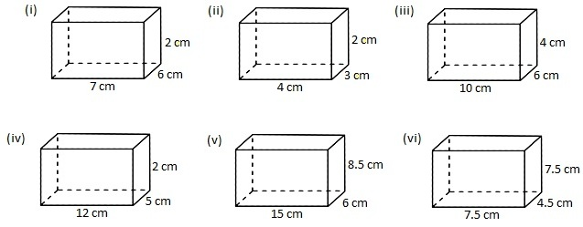
Answers for the worksheet on volume of a cube and cuboid are given below.
Answers:

1. (i) length × breadth × height 2. (i) 125 cu cm
(ii) Side × Side × Side (ii) 64 cu cm
(iii) 1 cu cm (iii) 216 cu cm

3. (i) 60 cu m 4. cuboid
(ii) 41472 cu cm
(iii) 240 cu m

5. 20000 6. 3000 cu m
7. (i) 84 cu cm
(ii) 24 cu cm
(iii) 240 cu cm
(iv) 1200 cu cm
(v) 765 cm³
(vi) 253.125 cm³

