Teacher Name: Sir Tahawur Class: 6 Subject: Mathematics Date: 09 November,2018

Evaluate the following.
1. 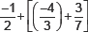
2. 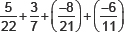
3. Find: 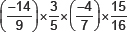

4. (3/4 + -2/5) + (-7/10)

5. {(-9)/5 × (-10)/3} × 21/-4

