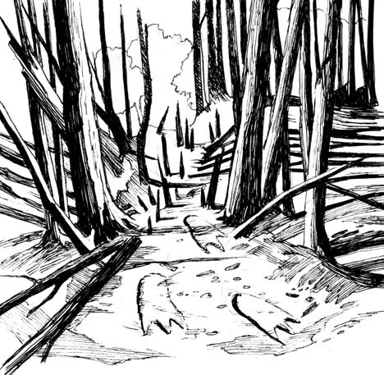
WRITING PROMPT
Every picture tells a story. Write a story, using this picture as the setting. What happens next?

#OPYRIGHT¹ BY%DUCATION COM -OREWORKSHEETSATWWW EDUCATION COM WORKSHEETS

