WRITING PROMPT
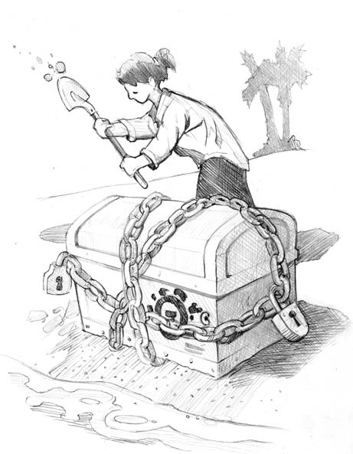Jenny digs up a treasure chest on the beach, and it turns out to be nothing but cursed with bad luck. What happens when she tries to bury it again?

Copyright © 2011-2012 by Education.com More worksheets at www.education.com/worksheets

