The City School
English
Grade VII
The Best Birthday Gift Ever!
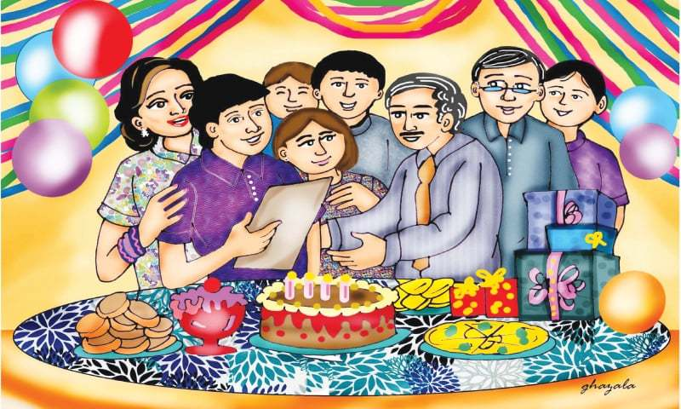
Beside my father and mother, in my family there is my elder brother Hashim, my younger brother Shahmeer and my younger sister Ilsa. Hashim is a teacher and is mostly out of the house. I remember his stories about the different students whom he had taught and the interesting experiences he has had.
When Hashim’s twenty-third birthday drew near, mum and dad decided to organise a birthday party. We did not have much to spend, but we knew that Hashim would be delighted with whatever we could manage. We also decided to give Hashim a surprise and vowed not to tell him until the last minute.
Hashim went about his routine, unaware of what we were preparing. Ilsa helped mum bake a cake while Shahmeer cleared the house and rearranged the furniture. Father promised to give me some money to add to what I had in my savings box so that I could buy a nice present for Hashim. Ilsa, however, refused to let us know what she intended to buy.
When the big day arrived, we all persuaded Hashim to go deliver a special curry mum had made to an relative so that we could surprise him on his return. He seemed confused by our unusual insistence, but he compiled. We quickly made the arrangements for the party, then dressed up and waited downstairs for his arrival.
Soon, we heard a knock at the door. Ilsa ran forward and flung it open and as she did, we all shouted “Happy Birthday, Hashim!”
To our great surprise, the man standing at the door was not Hashim but a stranger. He looked embarrassed and apologised for the intrusion and said he had no idea we were having a party. He then explained, “I am looking for Mr Hashim Ahmed.”
My father went out to talk to him and when he was fairly convinced that the stranger was commendatory, he invited him in. Just when the stranger had seated himself and was about to accept a glass of water from mum, there was a loud knock at the door. This time, in order to make sure it was really Hashim, Ilsa peered through the keyhole and waved excitedly at us. She flung the door open and we yelled out, louder than before, “Happy birthday, Hashim!”
Hashim walked in, beaming broadly and hugged everybody. All of us thrust our gifts into his hand. He put them all on the table and thanked us. Then he walked up to the dining and exclaimed at the size of the cake. It was then that he noticed the stranger.
Hashim could not recall meeting the stranger. The stranger, however, smiled and extended his hand, introducing himself as Javed Iqbal, a solicitor. The stranger said that he was there on the behalf of a certain Qasim Gafoor, a businessman. Some two years ago, Hashim had been involved in an incident in which he rescued Qasim Gafoor’s son — also Hashim’s student — from some kidnappers.
Solicitor Javed then told that the businessman had died some weeks ago and bequeath a hundred thousand dollars to Hashim for his kind deed in his will. Therefore, the solicitor had come to give Hashim’s share in the will. Perhaps the unexpected visitor had given Hashim the best birthday gift!

Answer the following questions:
- How many people are there in a family?
________________________________________________________________________________________________________________________________________________
- What routine does Hashim follow?
________________________________________________________________________________________________________________________________________________
- Why do you think Hashim’s family want to surprise on his birthday?
________________________________________________________________________________________________________________________________________________
- Do you agree Hashim has got the best on his birthday? Why or Why not?
________________________________________________________________________________________________________________________________________________
- Have you ever helped anybody? How did you feel after that?
________________________________________________________________________________________________________________________________________________

Creative Writing: (120-150 words)
Write dialogues between two friends discussing the advantages of regular physical exercise. You can talk about:
- How you manage physical exercise in your hectic schedule
- Benefits of exercising regularly
- Convince your friend to exercise daily
Write a letter to your friend telling him/her about an interesting movie you watched with your classmates. You can tell about:
- Name of the movie
- Interesting features of the movie including characters, setting and plot
- Persuade your friend to watch that movie
Grammar
- Fill in the gaps with superlative or comparative form of the adjectives given:
- A rock is ______________ than a leaf. (heavy)
- Bicycles are _______________ than motorbikes. (safe)
- It is the _________________ shop in town. (expensive)
- Tim is ____________________ than Peter.

- Change the following sentences into Passive Voice:
- The owner raised the alarm.
______________________________________________________________________________________________________________________________
- The police chief ordered his men.
______________________________________________________________________________________________________________________________

