Question Bank for Grade 7
Real Numbers

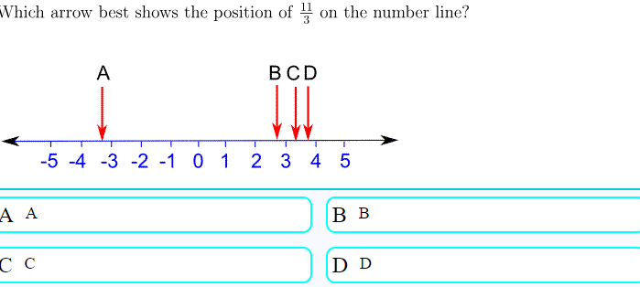

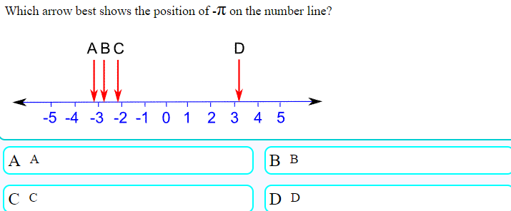
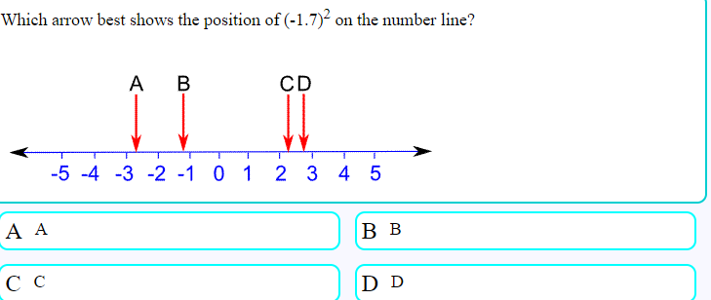

Real Numbers are just numbers like:
1 | 12.38 | −0.8625 | 34 | π (pi) | 198
In fact:
Nearly any number you can think of is a Real Number

Real Numbers include:
Whole Numbers (like 0, 1, 2, 3, 4, etc)
Rational Numbers (like 3/4, 0.125, 0.333..., 1.1, etc )
Irrational Numbers (like π, √2, etc )
Real Numbers can also be positive, negative or zero.
So ... what is NOT a Real Number?
Imaginary Numbers like √−1 (the square root of minus 1)
are not Real Numbers
Infinity is not a Real Number

Number Sequence
