Question Bank for Grade 8
Expansion and Factorization of Algebraic Expression

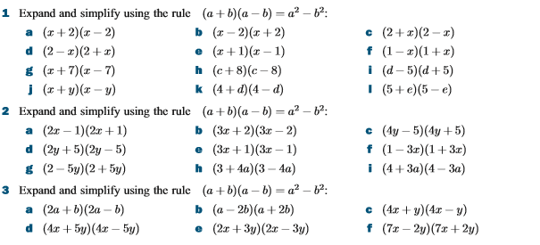

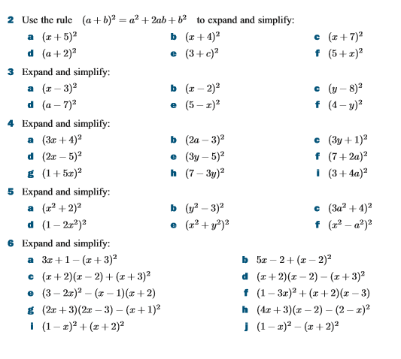
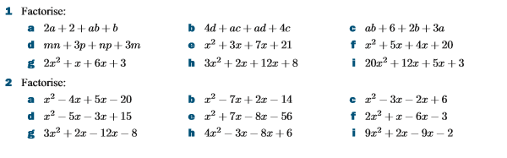
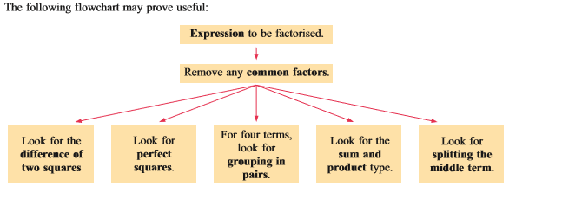
Sets
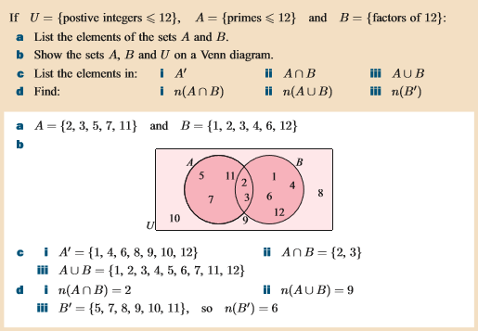
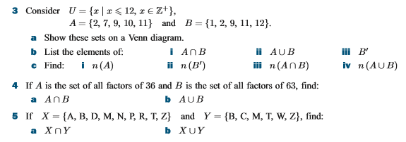
Polygons
Draw a regular pentagon.
Draw a regular hexagon.

Pythagoras theorem

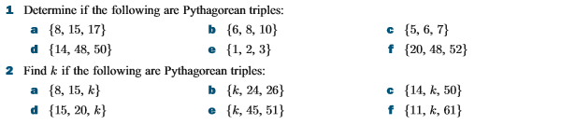

Algebraic Manipulation and Formulae
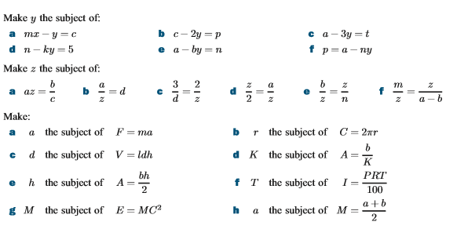
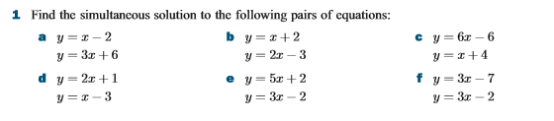
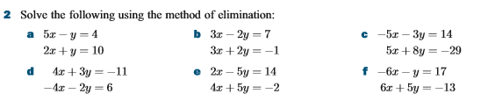
Statistics
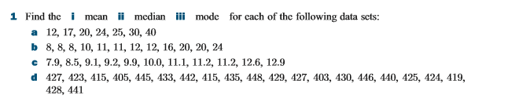
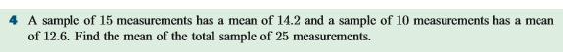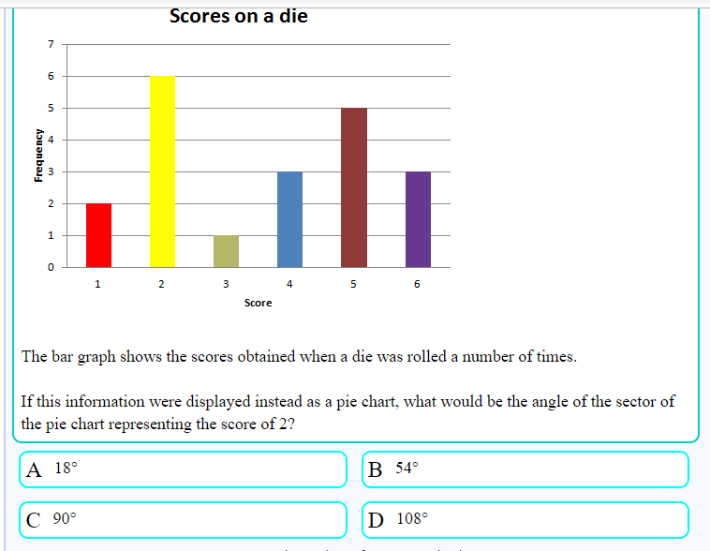
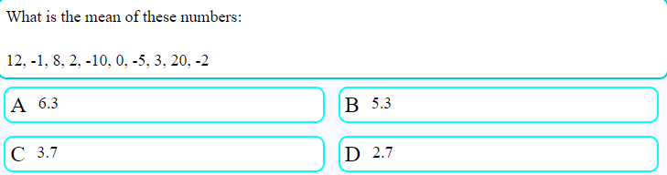
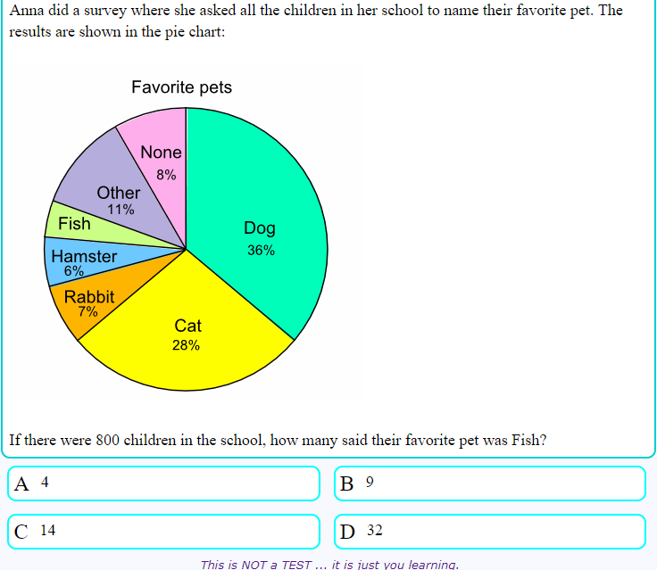

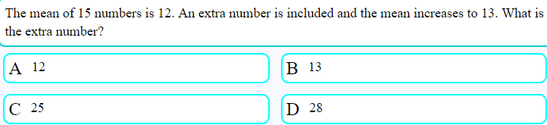

Q. The distribution of the lengths of time taken by an engineer to repair some washing machine of the table.
Time (t hours) | 1< t ≤ 3 | 3 < t ≤ 4 | 4 < t ≤ 5 | 5 < t ≤ 8
Frequency | K | 5 | 4 | 3
Histogram represents some of this information.
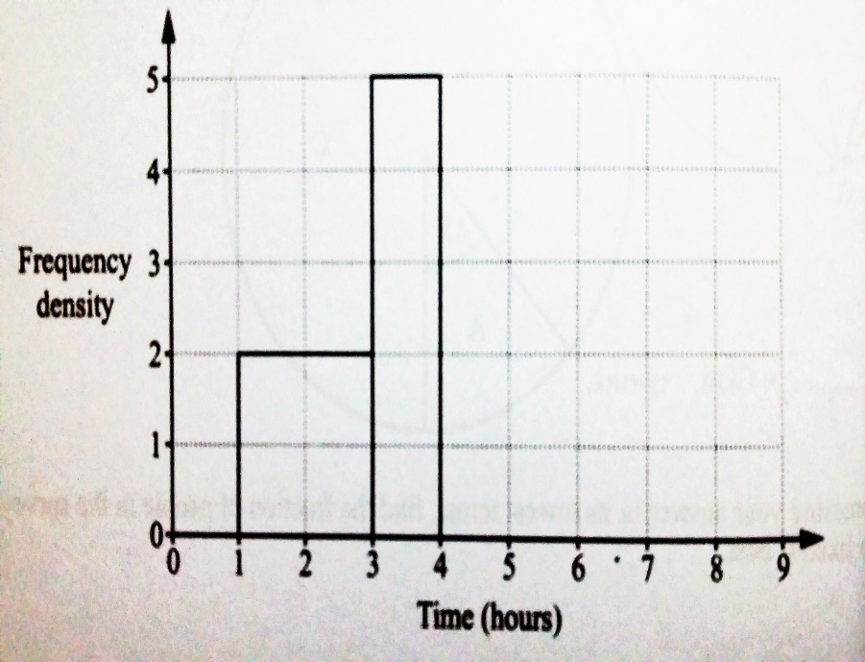

- Find k.
- Complete the histogram.

