 **The City School**

Southern Region

Class 7

Geography

Q1a. Differentiate between the phenomenon of cooling due to relief and cooling due to convention

currents. /2

b. Identify the reasons of the Monsoon climate. /2

c. “Equatorial Climate has some distinct characteristics.” What evidence you can find to support the

given statement? /4

d. How is the process of conduction different from convention? /2

Q2.

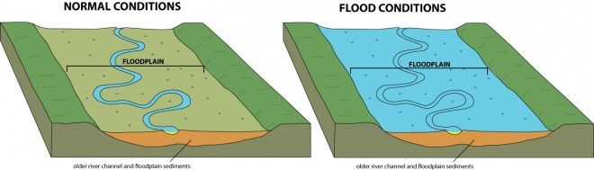 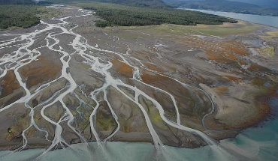

Insert A Insert B

1. Identify the Insert A________________________ and Insert B ________________ /2.
2. 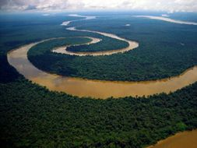Name the river feature shown in the insert below. /1

1. How are these formed? /4
2. What does the given picture tell us about the causes of water shortage? /3

