Geography Class 8
Reinforcement Questions

Q1a. Define the term Urbanization. /1
b. List down the advantages and disadvantages of urbanization. /4
c. Discuss any two advantages and two disadvantages mentioned in answer (b) /5

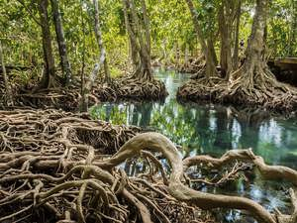
Q1a. Describe the mangroves trees. /4
b. What in your opinion are the reasons of the destruction of Mangroves? /2
c. Discuss the main features of main climatic zones of Pakistan. /4

