**The City School**

Sample Revision Questions

Class 8

History

**Section A**

Q1a. Page no.31, ***New form of government.***

“Enlightenment thinkers began…………………………………….. the French revolution (1789).

1. Identify the basic principles needed for the new system of government. /2
2. What in your opinion was better system of governance, the old or the new one? Give reasons for your answer. /3

b. Look at the given source and answer the questions.

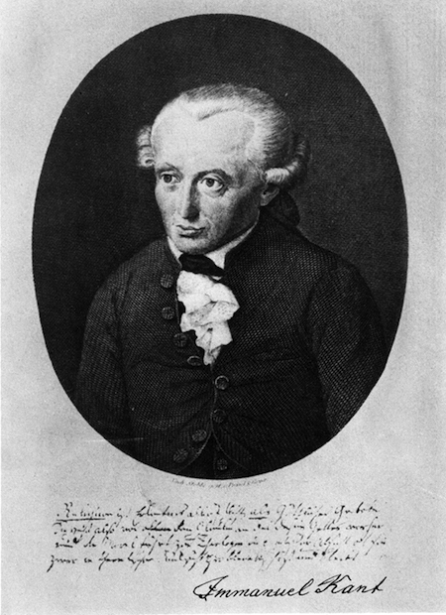

1. Identify the personality. /1
2. What was the motto of his movement? /1
3. How do you think his movement brought change among ordinary people? /3
4. Written source Page 54- sub heading ***What caused it***

“……..the fact is that for a long time…………………… by the Mutinous army.”

1. Who wrote these lines? /1
2. What does the writer meant by the phrase ”*vast store of explosive material had been collected”*

/3

1. Name the book from where these lines were taken. /1
2. Look at the picture ad answer the questions. 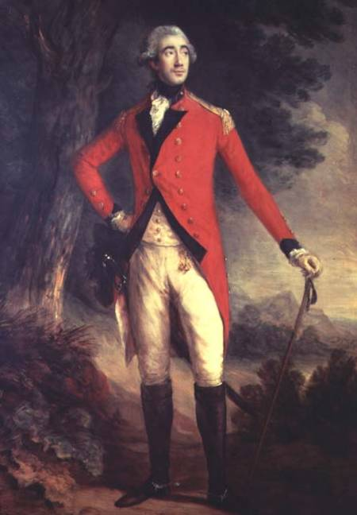
   * 1. Identify the personality. /1
     2. What was his policy of Indianisation? /1
     3. Highlight the reforms brought by the British reformers in social sector of India. /3

**Section B**

Q1a. How did India lost the peacock throne? /4

b. How can you prove that in the mid of 18th century the Company was making large profit?

/6

1. Do you agree that Robert Clive played a vital role in the establishment of British power in India? Give appropriate references to support your answer. /10

Q2a. What were the aftereffects of French invasion on Egypt? /4

b. Do you agree that the luxuries life of the Ottoman Sultans was the main reason of the

decline of Ottoman Empire? Explain. /6

c. “The economy of India subsequently changed from 1800.” What evidence can you find to

support the statement? /10