Teacher Name: Class: Subject: Date:
Zakia Amir 8th Science 5th Dec 2018

Q1: Fill in the blanks;
- Microorganisms spread through _______________ , _____________________.
- Proteins are broken down by __________________ enzyme.
- When light strikes the shiny surface it bounces back, this phenomenon is called ________________.
- Light is a form of energy that travels in the ______________ line.
- White blood cells produces ____________________ against pathogenic microorganisms.
- Our body has two defense system to get protected against diseases, natural barriers and______________________ immune system.
- __________________ provides instant energy to the body.
- Splitting of light into its component colors is called _______________________.
- Concave mirrors are used in parking lots because they provide ___________________ view.
- Convex mirrors are used in microscope and in ______________________.

Q2: Correct the wrong statements only:
- Heat cannot transfer through vacuum due to absence of particles.
___________________________________________________________________________
- In spectrum red color refracts more as it has the highest speed among all colors.
______________________________________________________________________________
- Black and dull surfaces are the good radiators of heat.
__________________________________________________________________________________
- Beri beri is the deficiency disease of Vitamin k.
_________________________________________________________________________________
- Vaccines are the suspensions of dead microorganisms which are used to stimulate the immune system against pathogenic microorganisms.
______________________________________________________________________________

Q3: Define briefly the function of White blood cells.
Q4: What chemistry works behind bread rising?
Q5: Write names of three infectious diseases caused by bacteria.

Q6: Label the diagram:

Q7: Label the diagram depicting refraction of light, and answer the following questions:
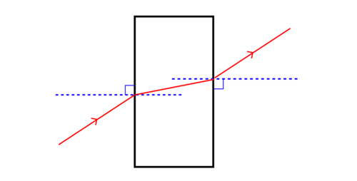

- Why does light bend when it enters the glass slab?
- Define apparent depth.

