Teacher Name: Fouzia Saleem Class: 6 Subject: Science Date:3rd May,2019
Q1. Look at the circuit diagram and answer the following questions.
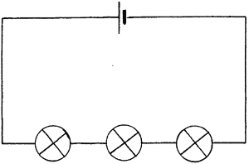
- What type of a circuit is shown in the diagram?
_____________________________________________________________________________
b. Give reason to support your answer.
________________________________________________________________________________
________________________________________________________________________________
- Do you think that this type of circuit will keep if one of the bulbs is broken?

________________________________________________________________________________
_________________________________________________________________________________
d. Draw a similar circuit diagram with one motor and three bulbs connected in the same type of circuit

