Teacher Name: Fouzia Saleem Class: 6 Subject: Science
Date: 5th April , 2019

Q 1. Identify the symbols of the electrical components shown.
Symbols | Name of the components
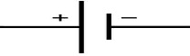
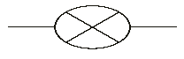

Q2. Differentiate between the following:

TRANSPARENT | TRANSCLUCENT
OPAQUE | TRANSPARENT

