Teacher Name: Fouzia Saleem Class: 6 Subject: Science
Date: 29th March,2019
Q1. The photograph below shows a set of day and night curtains.
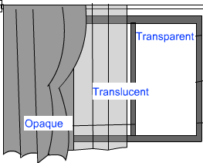
a. Which set of curtains is made of material which allows some light to pass through? Explain why this set of curtains requires such a material.
________________________________________________________________________________________________________________________________________________________________________________________________________________________________________________________________________________________________________________________________________
__________________________________________________________________________________
b. Which set of curtains is made of material which does not allow light to pass through? Explain why such a material is used for this set of curtains.
________________________________________________________________________________________________________________________________________________________________________________________________________________________________________________________________________________________________________________________________________
c. . Which set of curtains is made of material which allows most of light to pass through? Explain why such a material is used for this set of curtains.
________________________________________________________________________________________________________________________________________________________________________________________________________________________________________________________________________________________________________________________________________

