Teacher Name: Class: Subject: Date:
Seema Adil 7 Science 27th January 2017.

6.1 | Matter

- Matter is anything which has (1) ______________ and takes up (2) _______________.

A |  | The three states of matter

- 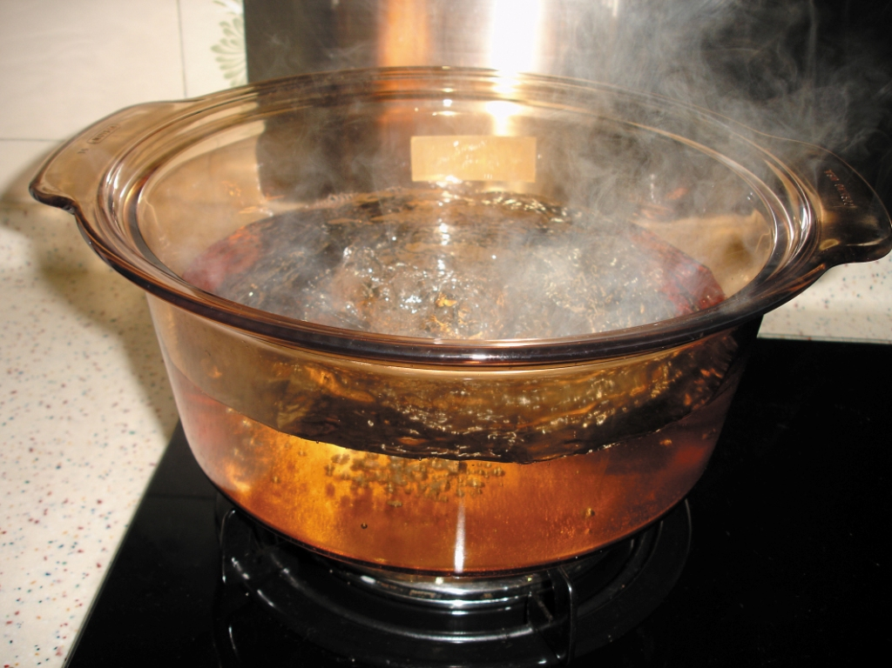Identify the three states of matter in the photo below:
The steam is a
(4) _______________.
The water is a
(5) _______________.
The pot is a
(3) _______________.

B |  | Properties of solids, liquids and gases (Book 1B, p. 134)

- What are the properties of solids, liquids and gases? Circle the correct answers.
 | Solid | Liquid | Gas
Shape | (6) fixed / not fixed | (8) fixed / not fixed | (10) fixed / not fixed
Volume | (7) fixed / not fixed | (9) fixed / not fixed | (11) fixed / not fixed

C |  | Change of states

- Complete the following table:
The temperature  that | ice melts and turns to liquid water | is called | - _______________ point.  It is (13) __________°C.
 | water boils and turns to steam |  | (14) _______________ point.  It is (15) __________°C.
 | water freezes and turns to ice |  | (16) _______________ point.  It is (17) __________°C.
- For the same substance, the (18) _______________ point and the (19) _______________ point are the same.
- The change of states of matter:
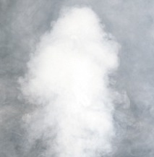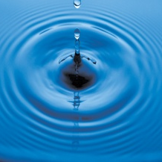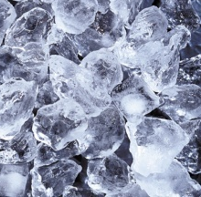
(22) ______________
(21) ______________
(20) ______________
(23) ______________
Gas Liquid Solid

- Melting, freezing and boiling take place at (24) _______________ temperatures. During these processes, the (25) _______________ of matter change.

