Teacher Name: Class: Subject: Date:

Seema Adil 7 Science 10th February 2017.

**1** An object that is dense is heavy for its __ __ __ __ __ __ .

x i f

d e

A solid has a __ __ __ __ __ volume.

n s e

d e

Solids are __ __ __ __ __.

**2** Solids stay in one place unless they are __ __ __ __ e d or p __ __ l __ d.

**3 True or false?**

Liquids have a higher density than solids.

Liquids do not have a fixed volume.

**4 Solid or Liquid? Copy the sentences below into the table.**

It has a fixed shape.

It can flow.

It cannot be squashed.

It cannot flow.

It cannot be squashed.

Its shape can change.

|  |  |
| --- | --- |
| **Solid** | **Liquid** |
| It has a fixed shape. |  |
|  |  |
|  |  |
|  |  |
|  |  |

**.**

2

##### Answer Yes or No

**1** Can a gas be squashed?

**2** Can a gas flow?



**3** Can a gas change shape?



**4** Are gases more dense than liquids?

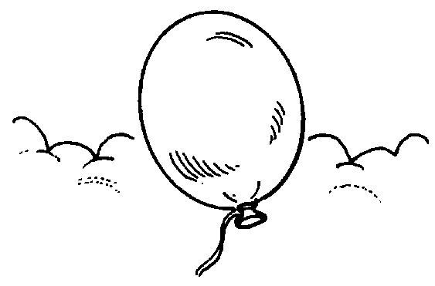

**5** Can the volume of the gas change?

**FILL UP THE CROSS WORD**

1

4

5

2

6

3

|  |  |  |  |  |  |  |  |  |  |  |  |  |  |
| --- | --- | --- | --- | --- | --- | --- | --- | --- | --- | --- | --- | --- | --- |
|  |  | **o** |  |  |  | **r** | **v** |  |  |  |  |  | **s** |
|  |  |  |  |  |  |  |  |  | **h** |  |  |  |  |
|  |  |  |  |  |  |  |  |  |  |  |  |  |  |
|  |  |  |  |  |  |  |  |  |  |  |  |  |  |
|  |  |  |  |  |  |  | **p** |  |  |  |  |  |  |
|  |  |  |  |  |  |  |  |  | **y** |  |  |  |  |
|  | **v** |  |  |  |  | **c** |  |  |  |  |  |  |  |
|  |  |  |  |  |  |  |  |  |  |  |  |  |  |
|  |  |  |  |  |  |  |  |  |  |  |  |  |  |
|  |  |  |  |  |  |  | **c** |  |  |  |  |  |  |
|  |  |  |  |  |  |  |  |  |  |  |  |  |  |
|  |  |  |  |  |  |  |  |  |  |  |  |  |  |
|  |  |  |  |  |  |  |  |  |  |  |  |  |  |
|  |  |  |  |  |  |  |  |  |  |  |  |  |  |
|  |  |  |  |  |  |  | **s** |  |  |  |  |  |  |

# Across

**1** Scientists think about these

and try to explain them.

**2** Scientists collect observations

or .

**3** A good idea is one that explains

a lot of .

# Down

**4** Science is about trying to

the world

around us.

**5** If an idea has been tested and

still works, it is usually called a

.

**6** A good idea can be used to make

.