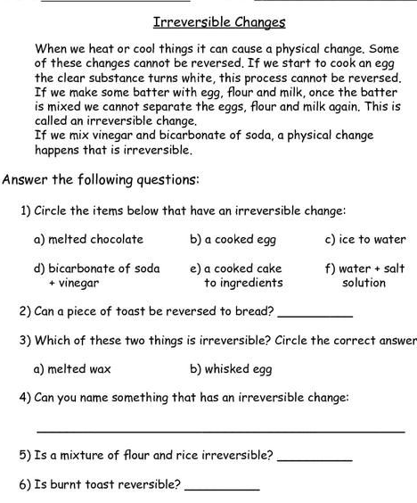
Teacher Name: Fouzia Saleem Class: 6 Subject: Science Date: 22nd February,2019

