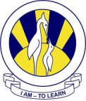
The City School
North Nazimabad Boys Campus
Worksheet
SCIENCE
Name_____________ Class___________ Sec_____ Date____

Q.1 Answer the following questions:

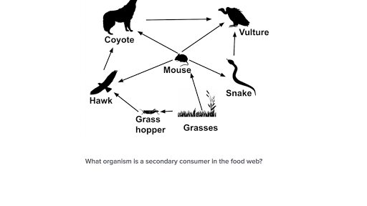
- Name the producers, primary consumers and secondary consumers.
- Construct a food chain from the above food web.
- What is likely to happen to the population of snake if the population of mouse decreases?
Q.2 MULTILPLE CHOICE QUESTIONS;
i.Things which are thrown away after one use are called
- disposables
- recycle able
- reduce able
- reusable
ii.Madagascar rosy periwinkle is used in treatment of
- blood cancer
- AIDS
- Hepatitis
- polio
iii.Clearing forest can lead to washing away of soil called
- erosion
- landslides
- weathering
- all of them
iv.A global phenomenon involving warming of earth's climate is termed as
- global warming
- greenhouse effect
- over-exploitation
- pollution
v. Marine animals specially fish when live in factory discharged waste water tends to get poisonous for humans and can cause
- death
- diseases
- both a and b
- development

