Teacher Name: Fouzia Saleem Class: 6 Subject: Science
Date: 1st February,2019
Q1. Define the following.
- Habitat: ____________________________________________________
________________________________________________________________
- Adaptation: ________________________________________________
________________________________________________________________
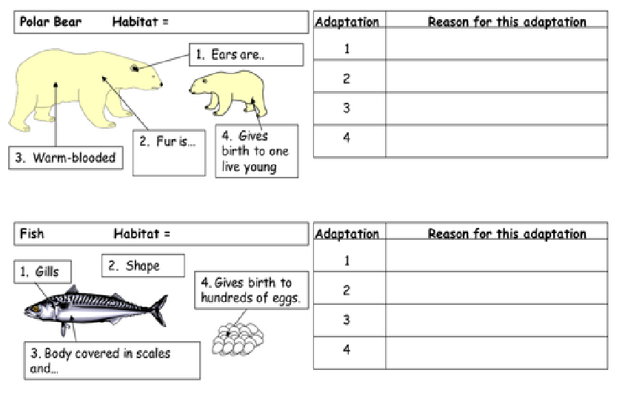
Q2. Write down the Habitats of the following animals and give reason for these adaptation.

