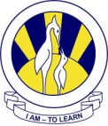
The City School
North Nazimabad Boys Campus
worksheet
SCIENCE

Name:_________________ Class: 7 Section:_____ Date:_____________

Q.1 Give one word answer for the given questions:

- Which cell’s primary job is to communicate messages throughout the body?
- What does the epithelial tissue protect the body from?
- Which cell organelle is responsible to control all the activities of a cell in plants and animals?
- What is the name of a red pigment made up of iron, present in red blood cells ?
- What is the name of a system of our body that provides us with basic framework, structure, protection and movement ?

Q.2 Differentiate between the following;
A PLANT CELL | AN ANIMAL CELL
VASCULAR TISSUES | GROUND TISSUES

Q.3 Study the diagram below and label the parts.
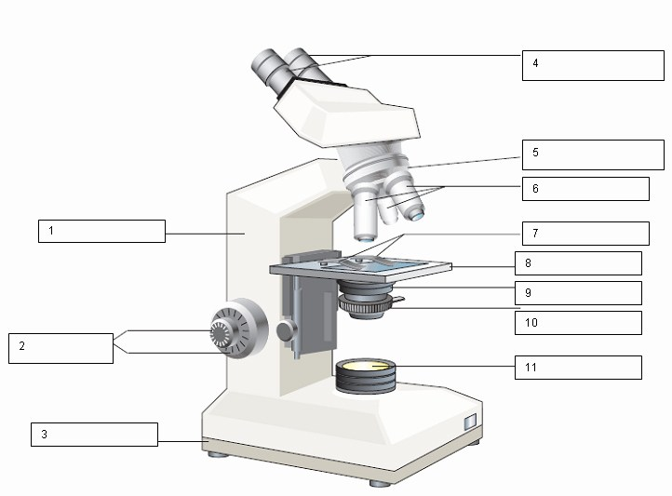A _______________microscope

Q.4 What are the main three principles o a cell theory?

