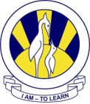
The City School
North Nazimabad Boys Campus
Worksheet
SCIENCE
Name_____________ Class___________ Sec_____ Date 1st March 2019

Q.1 Answer the following questions:

- What is used to indicate the flow of energy in a food chain or web?
- What happens to energy as we move from step to step in a chain or web?
- Define food web.
- What is meant by trophic levels?
- Define autotroph.
- Give an example of 3 detrivores. On what do they feed?
- What organism feeds on dead plants and animals and helps recycle them?
- Match each Food Chain Word to its Definition.
