The City School
North Nazimabad Boys Campus

SCIENCE 8
Name:_________________ Class: 8 Section:_____ Date:_____________

Q.1 Look at the list of nutrients.
STARCH SUGAR PROTEIN FAT VITAMINS MINERALS
Starch sugar protein fat vitamins minerals
a)Which of these must be digested before they can be absorbed.
b)Suggest why they need to be digested.

Q.2 What is the difference between?
Physical digestion chemical digestion

Q.3 What is a deficiency disease? Give one example of a deficiency disease.
--------------------------------------------------------------------------------------------------------------------------------------------------------------------------------------------------------------------------------------------------------------
Q.4.The walls of the small intestine are lined with thousands of tiny
villi.
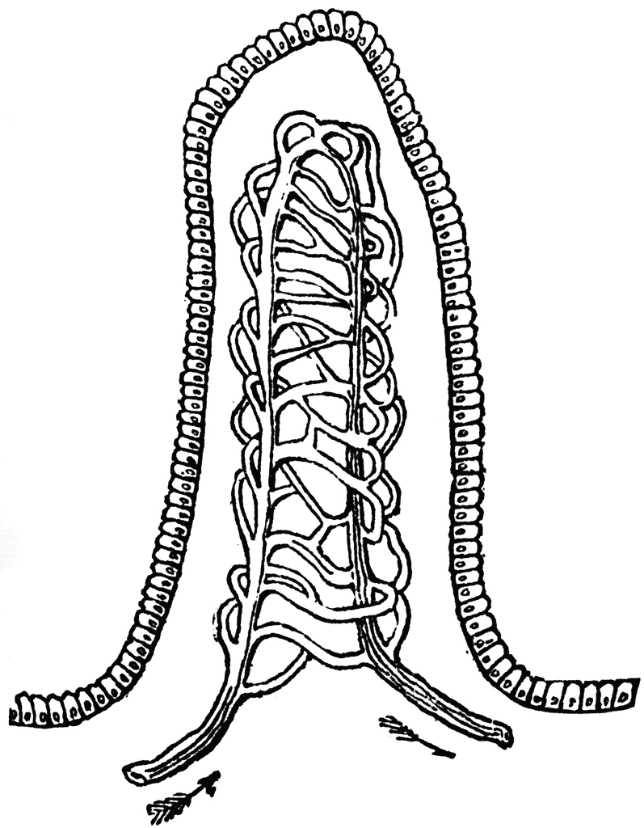
- What is the job of these villi?
- How do a large surface area help villi to do their job?
____________________________________________________________________________________________________________________________________________________________________________________________________________________________

Q.4 Give reasons.
a.. Why is it important to eat a balanced diet.
b. If fibre is not absorbed why do we need to eat it.

Q.5 Complete the following table.
Nutrient | Which foods are good sources of this nutrient
Fast
Carbohydrates
Proteins
Minerals

