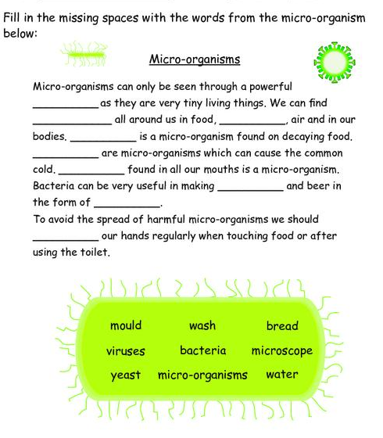
Teacher Name: Ms. Fouzia Saleem Class: 6 Subject: Science Date:2nd November, 2018

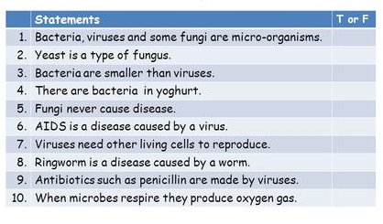
Q2) True/ False
.

