Teacher Name: Ms. Fouzia Saleem Class: 7 Subject: Science Date: 2nd November, 2018

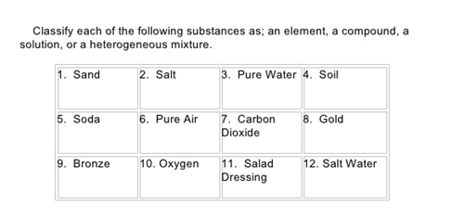
Q1.

Elements | Compound | Mixture

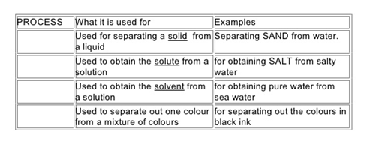
Q2.

