Teacher Name: Ms. Fouzia Saleem Class: 7 Subject: Science Date: 26th October, 2018
Q1. Study the pie-chart and answer the following questions.
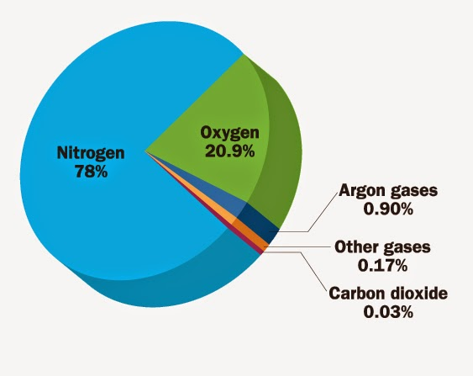
- What are the main gases which make up clean air?

- Which of the gases, including water vapour, are elements?

- Which are compounds?
_____________________________________________________________________________
- Which gas is present in the greatest amount in clean, dry air?

- Which gas is present in the least amount in clean, dry air?

___________________________________________________________________________
- What is the percentage of noble gases in the air?

___________________________________________________________________________

