Teacher Name: Class: Subject: Date:
Zakia Amir 8th Science 24th Nov 2018

Q1: Define Umbra and Penumbra. What kind of shadows are formed in extended light?
___________________________________________________________________________________________________________________________________________________________________________________________________________________________________________________________________________________________________________________________________________________________________________________

Q2: Observe the following diagram. Label it and answer the following questions.

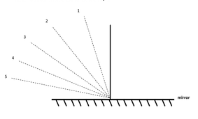

- Draw the path of rays of light as they are reflected.
- Explain how reflection can be used in everyday objects?
_______________________________________________________________________________________________________________________________________________________________________________________________________________________________________________________________________________________
Q3: What kind of image is formed by a plane mirror?
_______________________________________________________________________________________________________________________________________________________________________________________________________________________________________________________________________________________

