Teacher Name: Ms. Kiran Haq Class: 8 Subject: History Date: 26-Oct-2018
Q1: Use the given source to answer the following questions.

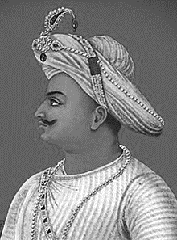
- Identify the personality in the given source.
Ans:_______________________________________________________________________
- What was the title given to him? Why?
Ans:_______________________________________________________________________
- Describe his qualities as a ruler.
Ans:___________________________________________________________________________________________________________________________________________________________________________________________________________________________________________________________________________________________________________________________________________________________________________________

