Teacher Name: Class: Subject: Date:
Zakia Amir 8 Science 9th Nov 2018

Q1: The graph below shows the heating curve of water. Use the graph to answer the following questions of water:
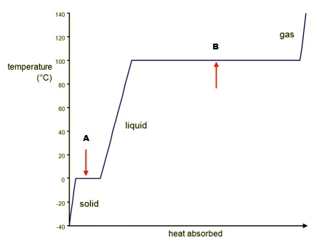

- What is happening at point A & B?
____________________________________________________________________________________________________________________________________________________________________
- What is happening to the energy being absorbed from the heat source at point A & B?
____________________________________________________________________________________________________________________________________________________________________
- What phase change is taking place at point A & B respectively and Why?
____________________________________________________________________________________________________________________________________________________________________

Q2: Give reasons for the following statements:
- Mercury in a thermometer rise on heating and fall on cooling.
__________________________________________________________________________________
- you feel cooler once your perspiration evaporates.
__________________________________________________________________________________
- We must be careful when using a thermometer.
__________________________________________________________________________________

Q3: Differentiate between heat and temperature.
_________________________________________________________________________________________________________________________________________________________________________________________________________________________________________________________________________________________________________________________________________________________________________________________________________________________

