CLASS 7
Unit 1
Source A
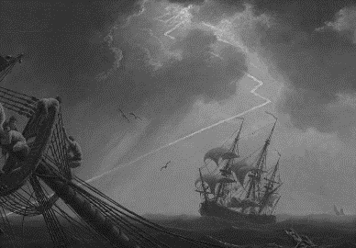

Q a: According to the given source A, what reasons were given by the survivors of shipwreck for not undertaking the sea voyages?
Source B
European overseas exploration led to the rise of global trade and the European colonial empires, with the contact between the Europe, Asia and Africa and America and Australia providing a way to transfer of plants, animals, food, human populations and culture. The Age of Discovery and later European exploration allowed the global mapping of the world, resulting in the distant civilizations coming into contact with each other.
- According to source B, how is the age of exploration important.
Q a: What makes the Europeans undertake the voyages of discovery? /4
b: “Apart from the trading benefits, the voyages of explorations has immensely effected the
world.” Explain by quoting appropriate references. /6

Unit 2:
Source A:
Sher Shah Suri
- What features made Sher Shah Suri a great ruler?
Source B:
Bābur was a military adventurer of genius and an empire builder of good fortune, with an engaging personality. He was also a gifted Turki poet, which would have won him distinction apart from his political career, as well as a lover of nature who constructed gardens wherever he went. Finally, his prose memoirs, the Bābur-nāmeh, have become a renowned autobiography. They were translated from Turki into Persian as well as in English, Memoirs of Babur,which is in two volumes, and were first published in 1921–22.
- According to the given source, explain what sort of personality Babur possessed?
Q a. Describe the secret weapons used by Babur against Ibrahim Lodhi? /4
- “Akbar established a strong empire.” Analyze the given statement in the light of his administration and consolidation strategies. /6

Unit 3
Source A:
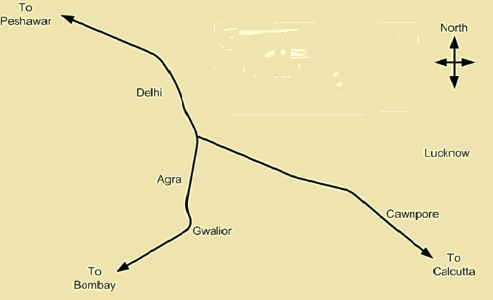
The Royal Road
- State the importance of the Royal Road built by Akbar.

Source B:
“NurJehan was the only Mughal Empress to have coins made in her name. Jehangir added the inscription: Bythe order of the Emperor Jehangir, gold has a hundred splendours added to it by receiving the impression of NurJehan the Queen Begum.”
- According to the source B, Comment on the position of NurJehan in Emperor Jehangir’s court.
Q a. Describe the religious policy of Shah Jehan? /4
- “Thatta was said to be an important city during Mughals.” Elucidate the importance of the city by quoting appropriate references? /6

Unit 4:
Source A:
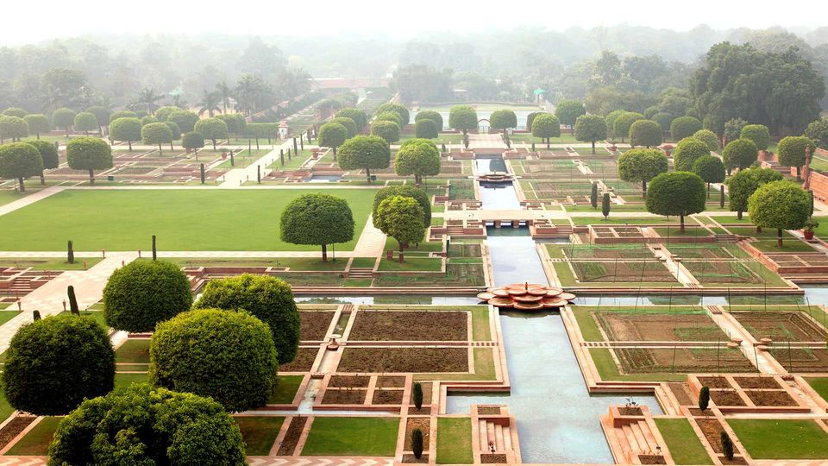
Mughal Garden
- Other than shade and leisure, highlight the significance of gardens created by the Mughal emperors.
Source B:
Mughal architecture is the type of Indo-Islamic architecture developed by the Mughals in the 16th, 17th and 18th centuries; throughout the ever-changing extent of their empire in the Indian subcontinent. It developed the styles of earlier Muslim dynasties in India as an amalgam of Islamic, Persian, Turkic and Indian architecture. Mughal buildings have a uniform pattern of structure and character, including large bulbous domes, slender minarets at the corners, massive halls, large vaulted gateways and delicate ornamentation.Examples of the style can be found in India, Afghanistan, Bangladesh and Pakistan.
a.Why is the architecture during Mughals, termed as Indo-Islamic?
b. Identify basic features of Mughal architecture.
Q a. How did the Mughal artists make brushes? /4
- “Jehangir was the soul and spirit of Mughal art.” Explain the given statement and support with relevant references. /6

