CLASS 8
Unit 1
Source A
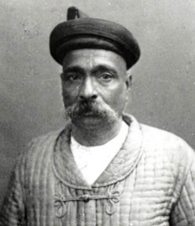

Q a: Identify the personality given in the picture.
b:What were the demands put forwarded by him to the British government?
Source B
The Simla deputation proved a landmark in the history of modern India, because for the very first time the Hindu-Muslim conflict, which stared with the Urdu-Hindi controversy, was lifted to the constitutional plane. The Indians were not satisfied with the Indian council Act of 1892. Especially, the act failed to ensure the fair representation of Muslims. So, the Indians were agitating for more power. Due to the growing political pressure and increasing social unrest, the British Government decided to make constitutional reforms relating to the electoral bodies.
- According to source B, highlight the significance of Simla Deputation.
Q a: What made the year 1919, a year of death and unrest? /4
b: Why was the formation of All India Muslim League a right step taken by the Indian
Muslims? /6
c: “The first World war was a deadly war.” Justify the statement by relevant references.
/ 10

Unit 2:
Source A:
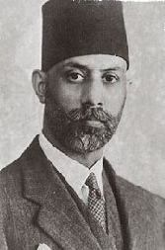
Chaudri Rehmet Ali
- Name the book written by him.
- Why ChaudryRehmat Ali suggested “Pakistan” as a name of country?
Source B:
“Jinnah and other fellow moderates did not participate in theKhilafat agitation. In a letter to Ghandi, Jinnah said that the movement was bound to lead to disaster. He said that this kind of a plan has appealed only to the illiterate and the inexperienced youth of the country. He said that though he had no power to remove the cause, he wished to advise his countrymen against the dire consequences of such an extreme act.”
- According to the given source, what type of consequences Jinnah was referring to?
Qa. What was Satyagraha? /4
- Why do you think Khilafat movement was not successful? /6
- “Kemal Attaturk revolutionized Turkey.” Do you agree? Explain with examples. /10

Unit 3
Source A:
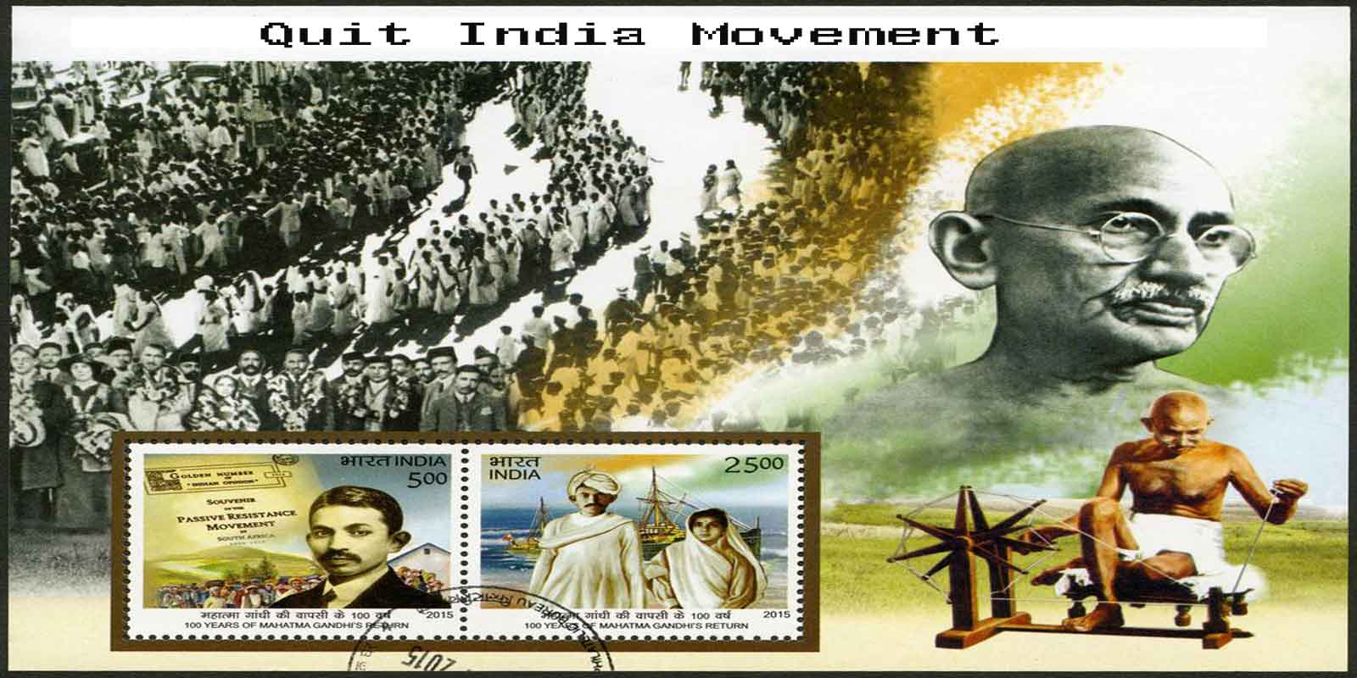
- What was the Quit India movement?
- Describe the impact of Quit India Movement on Indian Muslims.

Source B:
“Though the Muslim women were in strict “purdah” and were less and less politically aware, they played an active part in the independence movement. They formed the women’s branch of the Muslim League to organize women and inform them about the politics of the country. They organized public meetings for women and addressed large gathering. They had opened classes in their honour to educate Muslims girls. Thee brave ladies encouraged their brothers, husbands and sons not to give up the struggle for Pakistan until their goal was achieved.”
- According to the source B, describe the role played by the Muslim women in freedom struggle.
Q a. Describe the importance of Lahore resolution? /4
- Elucidate the reasons for the British unwillingness to partition sub-continent? /6

Unit 4:
Source A:

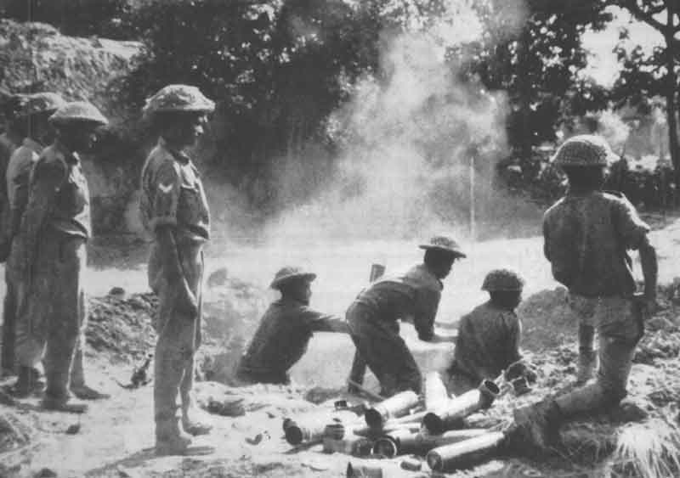
1971 war
- What were the major causes of outbreak of 1971 war between East and West Pakistan?
Source B:
The Khalistan movement is a Sikh separatist movement, which seeks to create a separate country called Khalistān in the Punjab region of South Asia to serve as a homeland for Sikhs. The Khalistan movement started around the time of partition of India when there were calls for an independent Sikh state but the idea was unviable due to lack of sufficient Sikh population as compared to other religions in Punjab. The boundary division gave Amritsar, sacred city for Sikhs to India and Lahore came to Pakistan leaving no power for the Sikhs who supported British throughout their rule in Sub-continent.
a. What made the Sikhs believe that the British will favor them during partition?
b. Why did the Sikhs started Khalistan movement?
Q a. What were the administrative problems faced by Pakistan in 1947? /4
b.“Unfair boundary division in the year 1947 creates many issues for Pakistan.” Explain the given statement and support with relevant references. /6
c. “Economically the partition of sub-continent in the year 1947 was completely mad.” Justify
thegiven statement with references. /10

