The City School
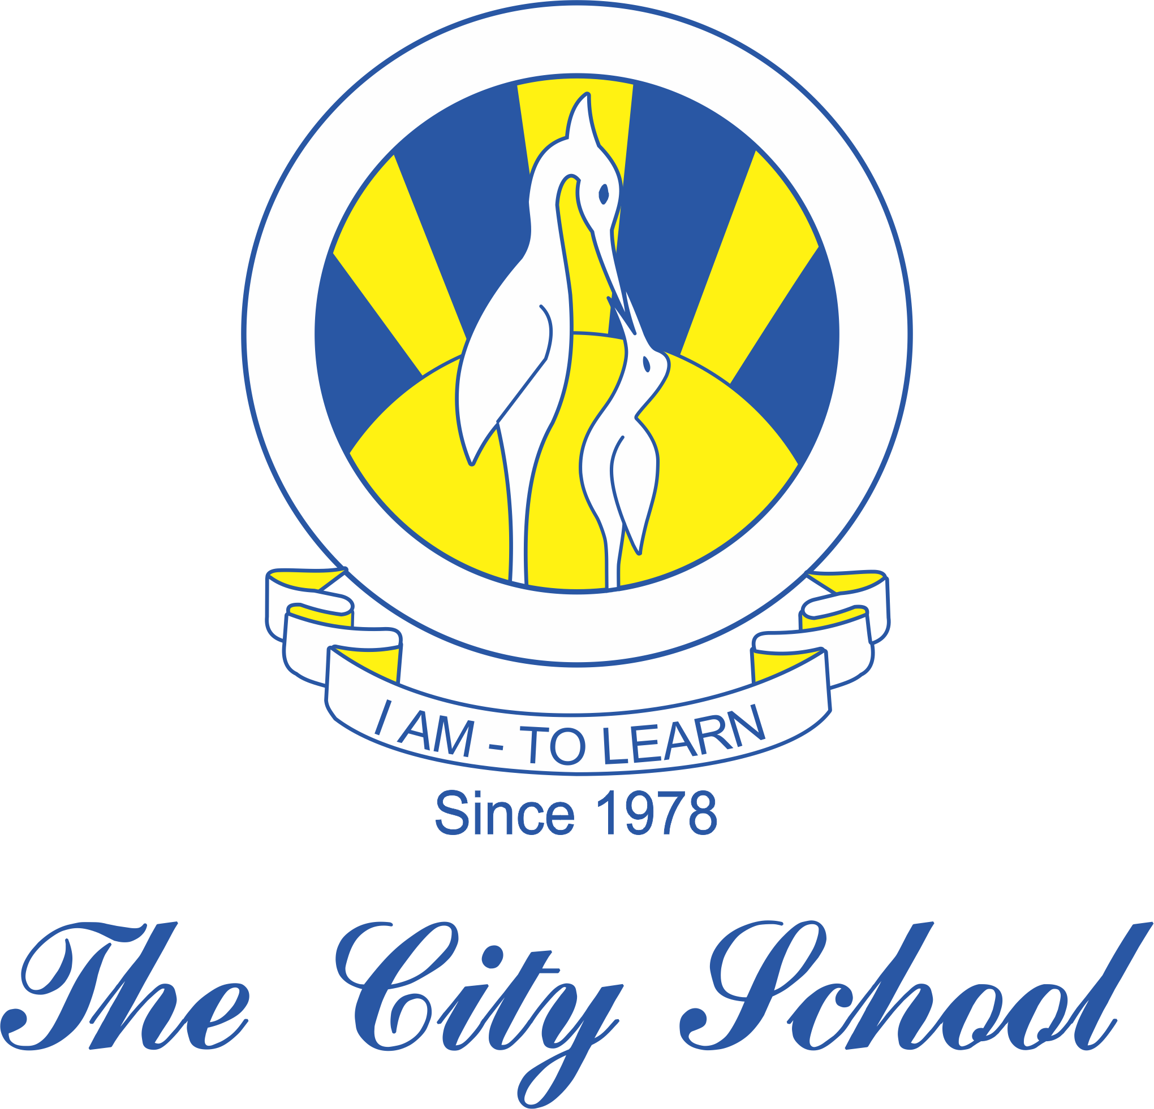
North Nazimabad Boys Campus
Syllabus for Class: 8
`Topics  Grammar  - Modal verb ‘should’  - Synonyms and antonyms  - Connectives  - Active and passive voice  - Phrasal verbs  - Similes, metaphors & personification.  - Punctuation marks  - Kinds of sentences  - Narration  Comprehension  Composition  - Report writing(newspaper report)  - Narrative writing  - Argumentative essay  - Formal / Informal letter  - Persuasive text (advertisement)  - Descriptive writing  Literature  Novel Book (Chap 1-9)  Themes of the novel  Character sketches | Learning Objectives  To analyze the concept of modal verbs with special emphasis on ‘should’.  To understand the difference between synonyms and antonyms.  Use connectives effectively.  To change the voices of the sentence.  Use phrasal verbs in speech and writing.  To extend the knowledge of idioms and metaphors and use them in writing text.  Understand and use the function of punctuation marks.  To study the different kinds of sentences  Change the speech as directed.  To comprehend the texts given in the OPE.  Identify features of different types of report.  Explore different techniques of story writing.  To write an argumentative essay on the given topic.  To convert the story of the poem into narrative.  To write a formal/ informal letter on  To design an advertisement for the mentioned product along with the logo and slogan of the imaginative company.  Gain knowledge of the difference strategies that are used in effective descriptive writing.  To examine the writer’s approach in the novel”The Hobbit”.  To analyze the plot’s development .  To identify and explain the themes of the novel.  To write the character sketches of all the major characters in the novel.

