The City School
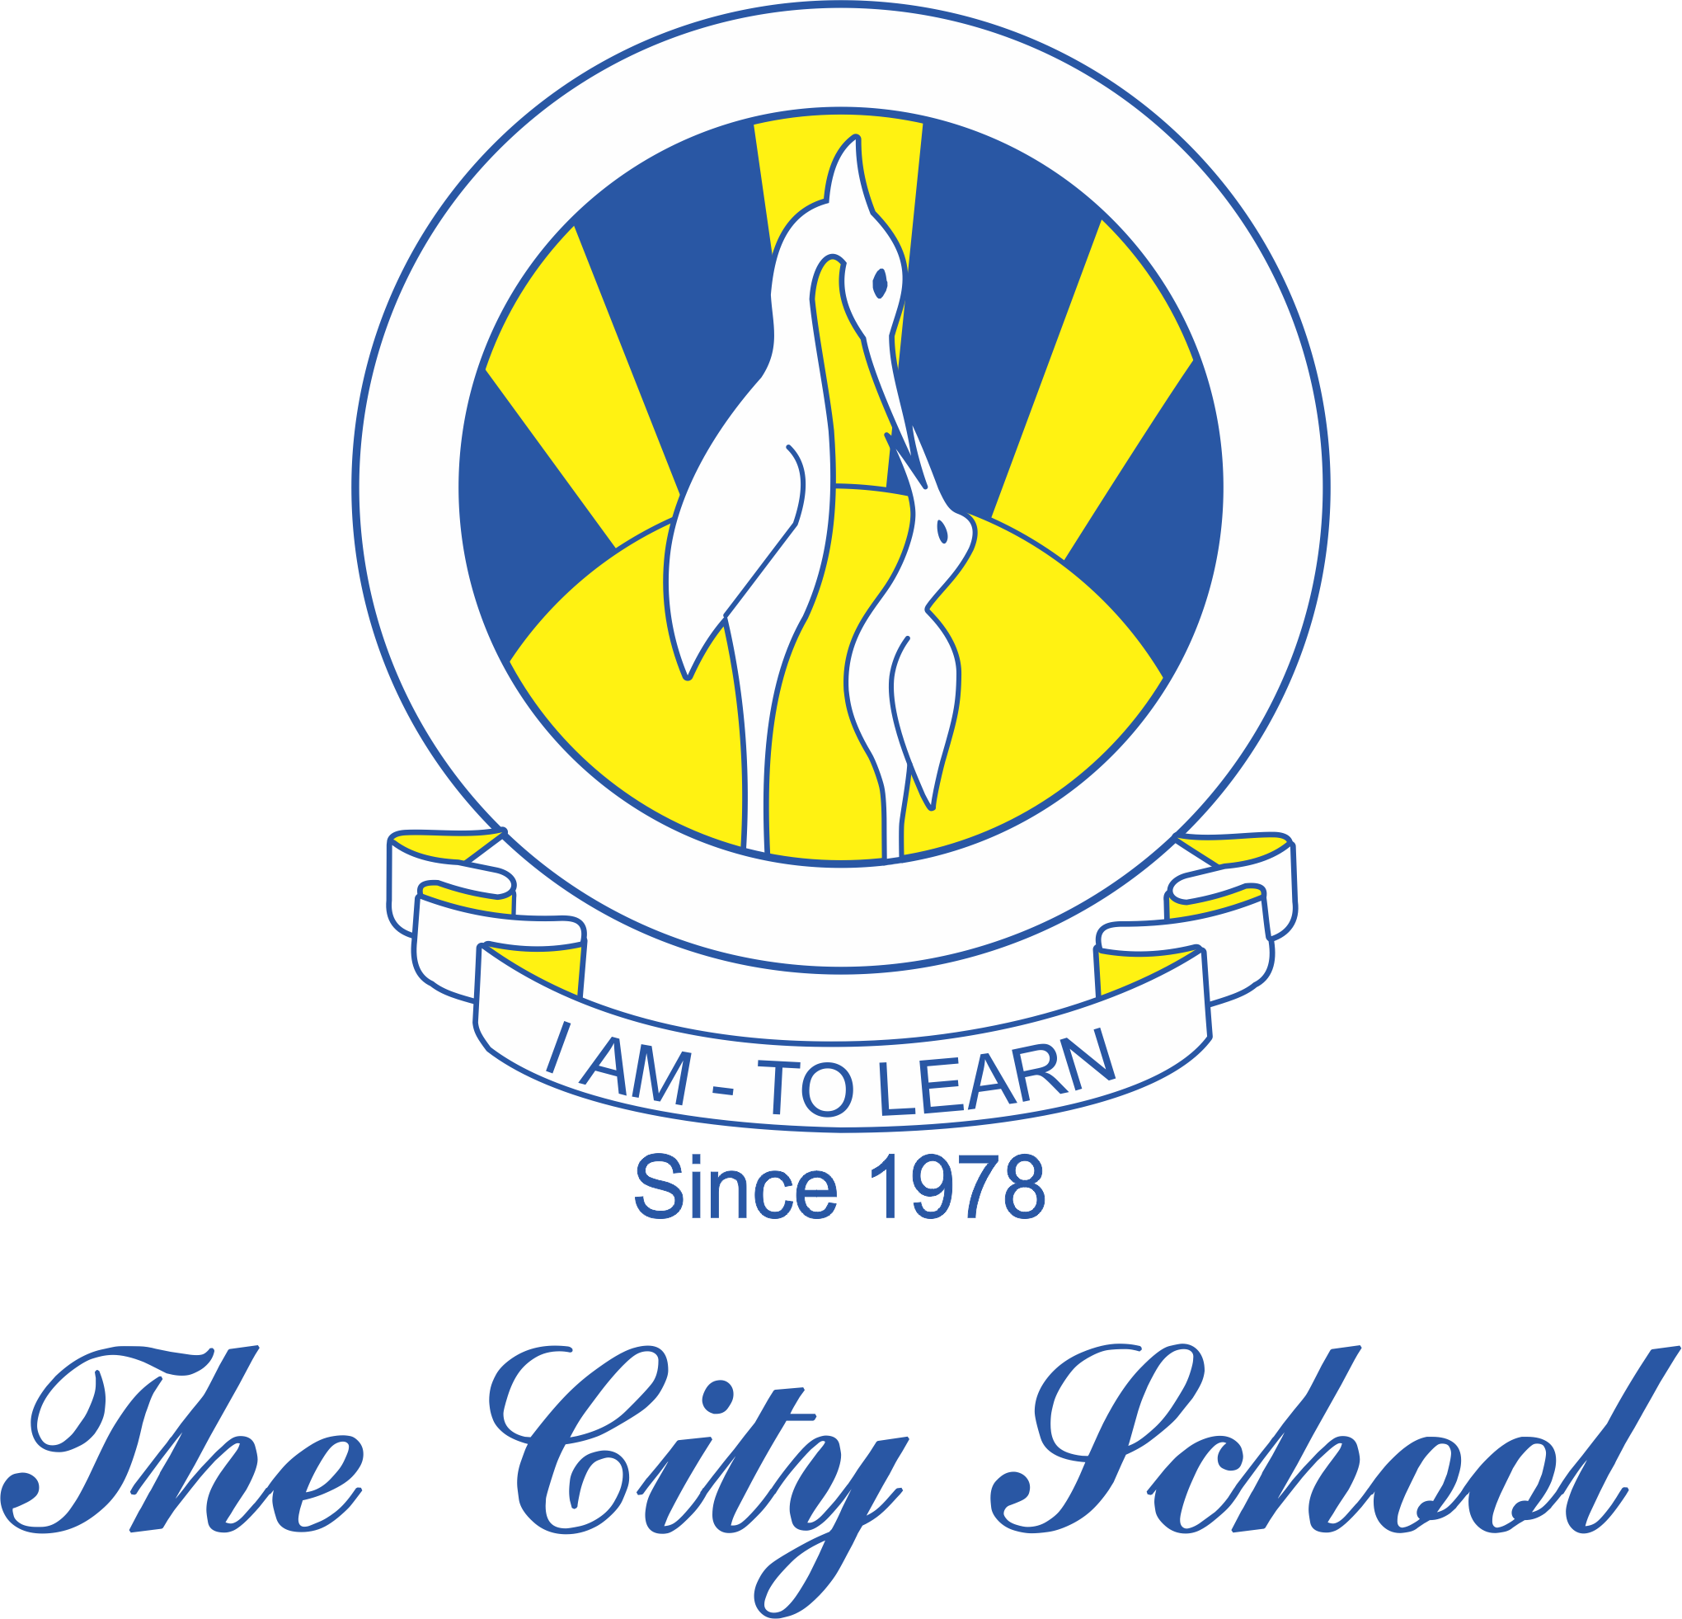
North Nazimabad Boys Campus
Syllabus for First Term 2018-2019
Subject: Geography Level: 8
Chapter 1: The Land of Pakistan
Chapter 2: Weather & Climate
Chapter 3: Population
Chapter 4: Natural Resources
Chapter 5: Environment

