The City School
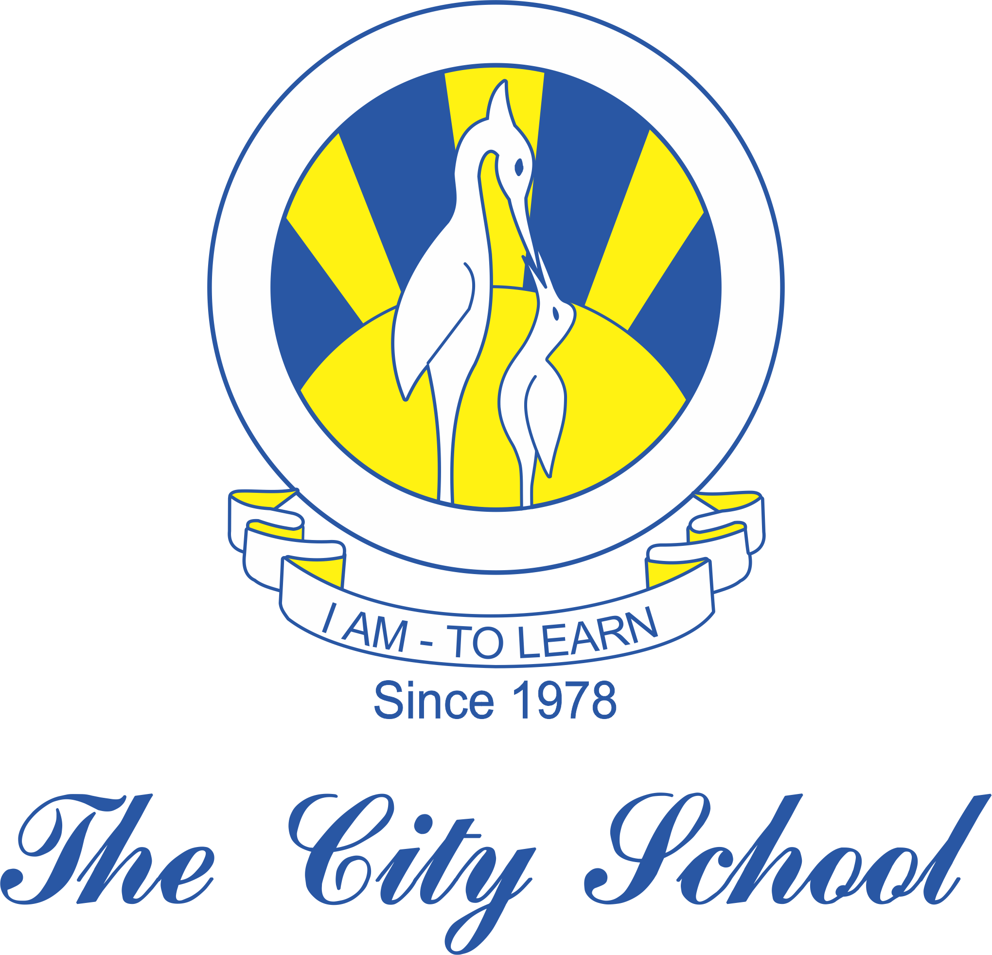
North Nazimabad Boys Campus
Syllabus for First Term 2018-2019
Subject: History Level: 8
Chapter 1: The Rise to the power of British in India (page: 3-21)
Chapter 2: The European Challenge (page:22-43)
Chapter 3: The British Raj in India (page:44-70)

