Self Evaluation | Level | CSI | Module | 5 | Task | 2 | Class
 | Student |  |  |  |  |  | Date

- Select the correct answer
- A Web browser is a computer system that delivers | web browsers  web pages  other web servers only
- Requests are sent from a | web browser to a web server  web browser to a web browser  web server to a web browser  web server to a web server
- A web hosting service is a company that maintains | web pages  web servers  web sites  web browsers
- A web hosting service can | be free  cost a fee  be both
- 000webhost.com is a | web browser  paid hosting service  free hosting service
- On a website, you can upload | only one web page  none web page  as many web pages as you want

- Select the correct answer
- SEO in ICT means | Search Engine Optimization  Search E-mail Optimization  Search Engine Online  Search E-mail Optimization
- A search engine scans the contents of a web page by looking for the relative | description  files and folders  keywords  browser
- On every webpage there is information that is | visible  invisible  visible and invisible
- Metadata is | extra information that helps search engines provide more relevant results  the information that is visible on every website and helps us find it easily  the visible and invisible information that is on a web page
- A description of a web page is | a detailed reference to the page’s content  the extra information that is at the end of the page  a type of metadata that summarizes the content of the page
- The search engine which still takes metadata keywords into consideration is | Google  Bing  AltaVista  ASK  Yahoo

Watch the HTML code below and write down its title, keywords and description.
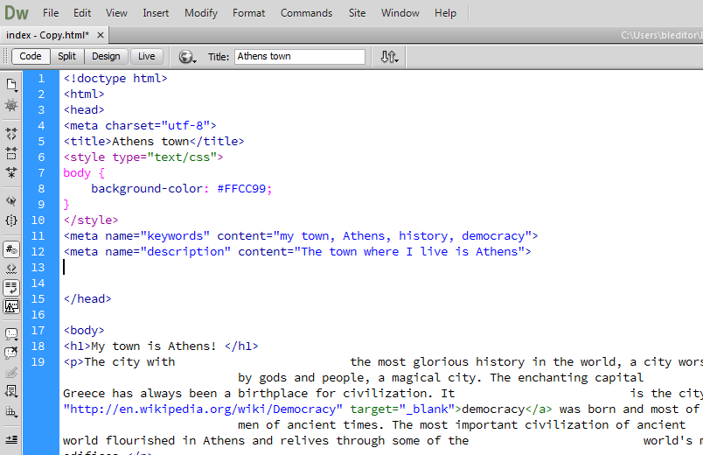
Page’s title | Keywords | Description

