**A completed website**



**Up until this point you’ve learned how to create a single web page. But how many web pages could a website consist of? What elements can you add to a web page? Let’s investigate these questions.**

**Let’s recognize tags**

* In the following script you can see an HTML code of a web page. Can you recognize the different tags? Look at it carefully and then fill in the table:

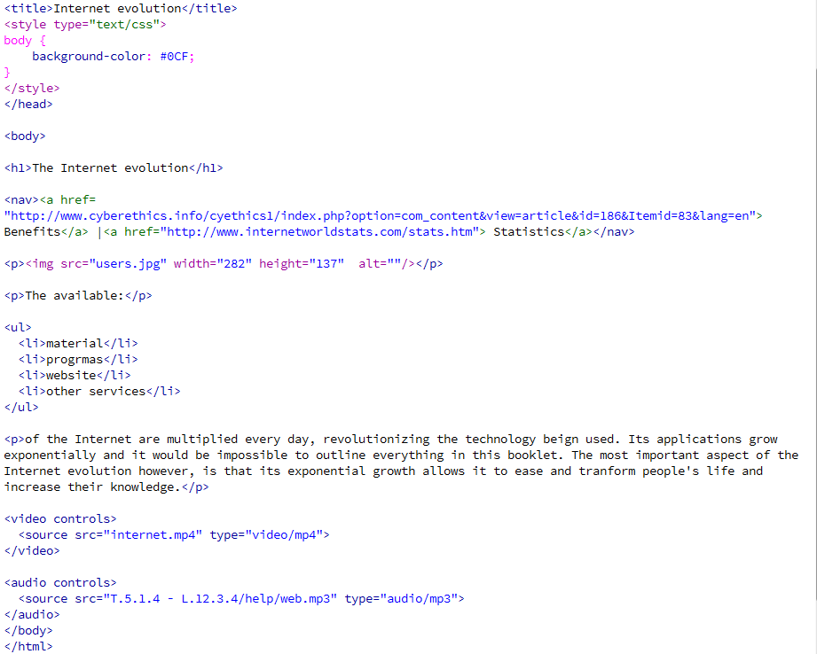

|  |  |
| --- | --- |
| **Write down the tags of the:** | |
| **Navigation toolbar** |  |
| **Title** |  |
| **Video** |  |
| **Image** |  |
| **Sound** |  |
| **Links** |  |
| **List** |  |
| **CSS rule** |  |