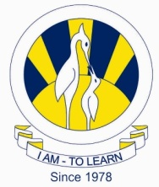
The City School
North Nazimabad Boys Campus

Dear Parents,

PE uniforms for students will be available at all Tariq Book shops in Karachi w.e.f 28th Sep, 2015. Details of outlets are as under:
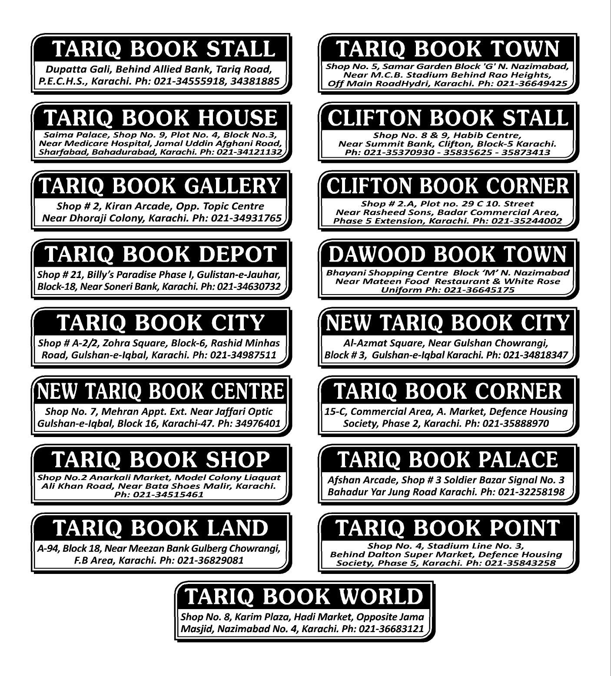

Regards,
Mehar Naz Hossain
Headmistress
North Nazimabad Boys Campus

